Asia’s pollution triggers storms in the USA

A new study find a link between smog in China and the weather in North America.
Steff Gaulter Last updated: 16 Apr 2014 09:36

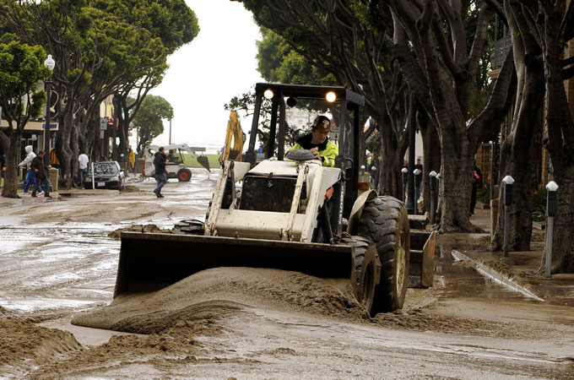
Pollutants from Asia can increase the formation of clouds by between 20 to 50 percent. [EPA]
Beijing is legendary for its pollution, but now a new study suggests that the poor air quality in Asia is affecting the weather elsewhere in the globe.
The study, by researchers at Texas A&M University in the US, found that smog from Asia directly affects the weather in North America.
It is already common knowledge that the weather around the world is linked, and what happens in one place can have a dramatic effect on the weather elsewhere in the globe.
The same principle applies to pollution: it can have a far-reaching impact. A number of previous research papers have shown that the drought that struck West Africa in the 1980s was caused, at least in part, by the coal-burning factories in the USA and Europe.
The pollution caused by these factories cooled the entire northern hemisphere, shifting the African monsoon southwards.
This situation was reversed when the clean-air legislation was passed in the USA and Europe, allowing the air to clear, and the rain band to shift northwards once more.
Now researchers have determined a clear link between Asia’s pollution and the weather in North America, although how much of an effect there is remains unclear.
Storm systems from Asia usually track across the Pacific towards North America, but the smog pollution can affect this.
Smog is comprised of various tiny particles, from sulfates and nitrates, to soot and soil dust. These particles could help clouds form.
In order for water vapour in the atmosphere to become a water droplet within a cloud, it must have something to condense onto, a nucleus. If there are no nuclei, then a cloud will struggle to form.
Scientists at Texas A&M University argue that the particles in the smog could provide these nuclei, and the study found they can increase the formation of deep convective clouds, by between 20 and 50 percent. This could result in more intense storms.
Both China and India have experienced widespread economic growth in recent years. Large, dirty factories and power plants, combined with the effects of wood and coal burning stoves, have meant that the countries are both in the top three of the world's largest contributors of man-made air pollution.
China is fully aware of its air-quality problem, and has enforced strict measures in Beijing in order to try to combat the problem.
However, the problem is not confined to just the capital. The Beijing Environmental Protection Bureau today announced that a third of the pollution in the capital actually comes from outside the city. Significant levels of pollution come from the surrounding provinces, including Hebei, home to seven of China’s ten most polluted cities.
While China struggles to take control of its air quality, more research is needed in order to determine exactly how the pollution is changing the weather in North America. If the pollution is also changing the track of storms, there could be a risk that it is exacerbating the drought in California.
This research may be a bitter pill to swallow for those people in the USA who have been hit by severe weather in the last few years. However, it may be worth remembering that the second largest polluting country is still the United States.
The world’s weather is intricately linked. What happens in one part of the world, can greatly impact someone in a completely different location, but there is no longer any doubt that human activity is changing the global weather.

